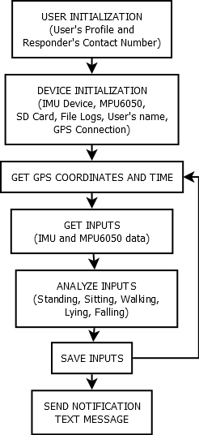

Figure 1: Block Diagram

As seen in Figure 1, the system will have two initialization phases. First is the User Initialization where the user must insert the microSD card into a laptop and access the GUI to set its name, gender, age, address and contact number. The user must also set a username and password that will be used when modifying the activity log, deleting or adding new responders, and updating its profile. The user must input at least one (1) responder for the first initialization phase to be done. The first initialization phase is only done once, only when setting up the system. The second initialization phase will run every time the device is turned on. This is where the device turns on all the required modules connected on it. The second phase also accesses the microSD card to get the information like the username of the user, and file logs. After the initialization, the device will now continuously get the time and GPS coordinates, monitor the motion, and orientation of the user, and save it the data to the microSD card for future reference. When the device detects a sudden fall, it will send notification text message to the responders found in the microSD card if the false alarm button was not pressed after 10 seconds.

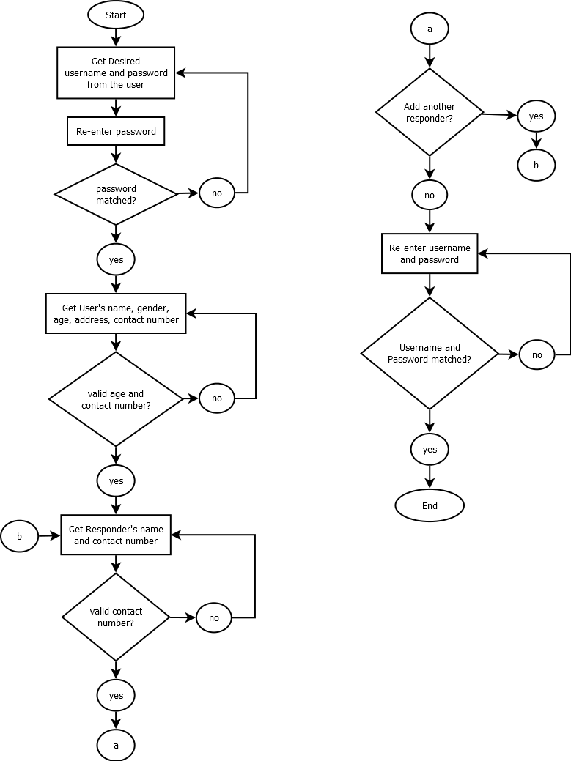

Figure 2: User Initialization

The User Initialization phase, which is run in the GUI has four (4) steps. The user must first set its username and password. The system also asks for a confirmation password before proceeding to the next step. If the confirmation password and the password did not match, the user must re-enter it again. The second step takes the user’s first and last name, gender, age, address, and contact number. The user must enter a valid age and contact number or else, it cannot proceed to the third step. The third step is where the user set its responder’s name and contact number. It must set at least one (1) responder or else, it cannot proceed to the last step. The last step for this initialization is to re-enter the username and password of the user, if matched, the initialization is done and the user must now attach the microSD card to the device.

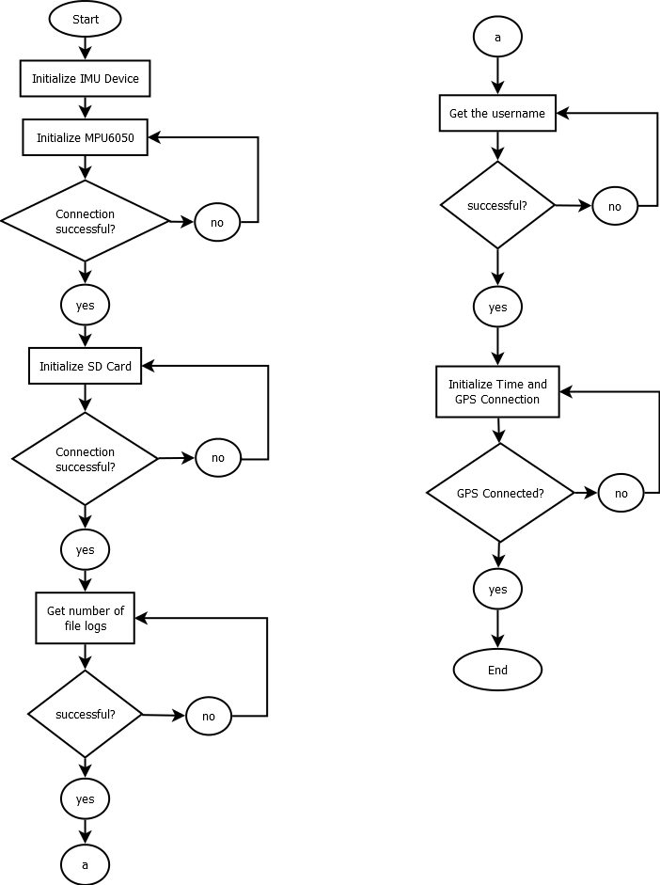

Figure 3: Device Initialization

In Device Initialization, all the modules needed to run the device is turned on. The IMU device is initialized first then the MPU6050 follows. Those two modules are used to get the readings of the accelerometer attached to the hip and waist of the user. When connection is successful, the microSD card module will be initialized. File logs will be accessed next to get the number of file logs and activity logs existing on the microSD card. The username of the user will be accessed for it will be used when send a notification text message to the responder. The last step on this initialization is turning on the GPS module that sets the time and GPS coordinates of the user.

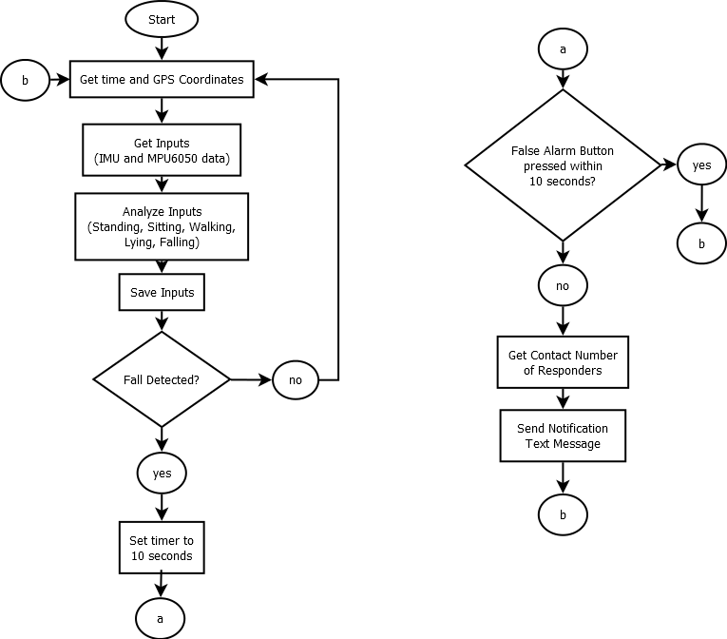

Figure 4: System Flowchart

After the initialization part, the device will continuously get the time and user’s GPS coordinates, get the user’s orientation and motion, and save it to the microSD card. If the device detects a sudden fall motion, it will start a 10 seconds timer. If the user did not press the false alarm seconds within 10 seconds, the device will get the contact number of the responders and send them a notification text message that includes the name of the user, time when sudden fall is detected, and its GPS coordinates.

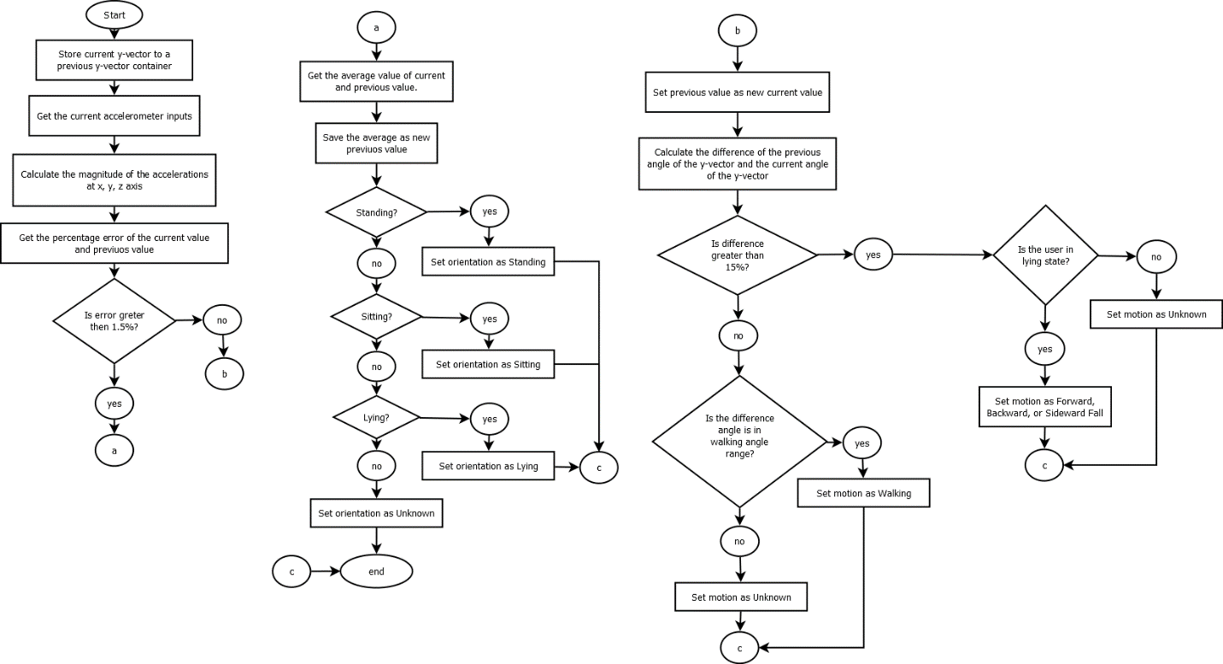

Figure 5: Input Analyzation FlowChart

The first step is to store the current y-vector to a previous y-vector container. Then get the new accelerometer inputs. The new inputs will be used to get the magnitude of the accelerations from x, y, z axis. After getting the magnitude, the percentage error between the current and previous values will be calculated. If the error is greater than 1.5%, the magnitude of the current value will become the previous value because there is no consistency, meaning, it is in dynamic motions like walking and falling. Else, it is in static motions like standing, sitting, or lying.

If it is in Dynamic motion, the difference between the current and previous angle of the y-vector will be calculated to determine if the magnitude error is greater than the gravity magnitude. If there is greater force than the gravity acting on the user, the device will check if it is lying position, if yes, the device will set the motion as forward, backward, or sideward fall. If no, the difference angle will be checked if it is in the walking angle range. It will then also check if the acceleration for walking is met. If the two parameters were satisfied, the device will set the motion as walking. If not, the current and previous value will be averaged and will be equal to the new previous value because the error is very minimal that makes it a static motion.

If it is in Static motion, it will check whether the inputs are equal to the standing, sitting, or lying position. If it matches one of the three (3) possible position, it will set the orientation as one of them, else, it will set the orientation as unknown.

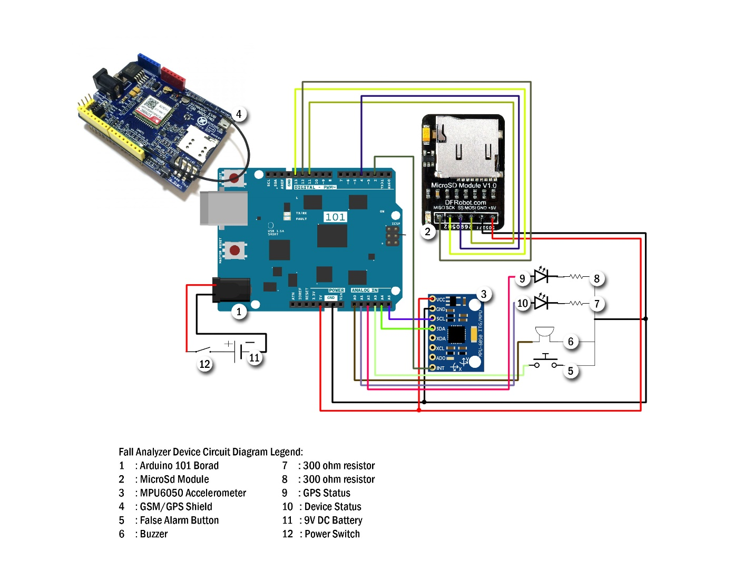

PIN CONNECTIONS:

MPU6050 Accelerometer to Arduino101:

VCC ---> 5v

GND ---> GND

SCL ---> A5

SDA ---> A4

INT ---> D2

microSD Module to Arduino101:

MISO ---> D12

SCK ---> D13

SS chipSelect ---> D4

MOSI ---> D11

GND ---> GND

VCC ---> 5V

GSM/GPS Shield to Arduino101:

Stack

Buzzer to to Arduino101:

GND ---> GND

Positive Pin ---> A0

Device Status Indicator:

GND ---> GND

Positive Pin ---> A1

GPS Status Indicator:

GND ---> GND

Positive Pin ---> A2

False Alarm Button:

GND ---> GND

Positive Pin ---> A3